GLADPHARM
Assessment
report

Table of Contents
Purpose 2
Scope 2
Out of Scope 2
Definitions 3
Business overview 4
Business Background 4
Problem statement 4
Main Business Challenges and Needs 5
Applications Infrastructure 6
System Landscape 6
Data Processing 8
Data Migration needs 8
Performance requirements and data transfer requirements. 9
Users and roles 10
Data classification and related risks 11
Network Architecture 13
13
Security and Compliance needs 14
Resilience, Availability, and disaster recovery requirements 16
Scalability 16
Backup and Recovery 17
Component SLA 17
Recommended changes and improvements 17
Use Cases 18
Proof of Value (POV) Use Case Scope 19
Data Processing 20
Applications Infrastructure/networking components 24
Visual representation of As IS vs Future Landscape 25
Deployment Plan 30
Budget 30

Introduction

Purpose

The purpose of this document is to present the main findings from the assessment conducted. It also defines the project's boundaries across various dimensions, including approach and roadmap, and serves as an agreement between the project team, the project sponsor, and key stakeholders. This document is intended for both business and technical audiences and does not cover the actual system implementation or provide detailed technical guidelines, projections, or presumptions. The Assessment Report covers both business and technical contexts without focusing specifically on either, emphasizing how the technical system implementation benefits the business. This report includes business challenges and recommendations from the analysis phase, and complements the accompanying documentation, deliverables, and diagrams. It is designed to serve as a guide for future teams and resources in implementing Gladpharm future state data platform.

Scope

- Data from multiple sources (ERP, MS SQL and more)
- Main business challenges in data ecosystem
- System Landscape
- Performance requirements and data transfer requirements.
- Users and roles
- Applications Infrastructure/networking components
- Security and Compliance needs
- Recommended changes and improvements
- Proof of Value Use Cases
- Proof of Value Scope
- Deployment Plan

Out of Scope

- Analysis of current business processes.

Definitions

Definitions and Abbreviations

# | Term | Description
1 | DWH | Data Warehouse
2 | REST | Representational State Transfer
3 | API | Application Programming Interface
4 | ETL | Extract, Transform, Load
5 | ELT | Extract, Load, Transform
6 | POV | Proof of Value
7 | BI | Business Intelligence
8 | BG | Business Goal
9 | CI | Continuous Integration
10 | CD | Continuous Delivery/Continuous Deployment
11 | CSV | Comma-Separated Values
12 | GB | Gigabyte
14 | SQL | Structured Query Language
15 | DB | Database
16 | EoM | End of Month
17 | EoQ | End of Quarter
18 | EoY | End of Year
19 | SLA | Service-Level Agreement
20 | DEV | Development
21 | PROD | Production
22 | VLAN | Virtual Local Area Network
23 | RBAC | Role Based Access Control
24 | HTTPS | HyperText Transfer Protocol Secure
25 | VM | Virtual Machine
26 | ODS | Operational Data Store

Business overview

Business Background
Gladpharm Ltd is a Ukrainian pharmaceutical manufacturer established in 1996 that has grown into one of the leading domestic players. Its core business involves developing, manufacturing and supplying generic medicines across several therapeutic areas including cardiology, endocrinology and gastroenterology, while adhering to international-GMP standards.
From the business-perspective, Gladpharm places emphasis on building resilient local production capabilities, investing in modern infrastructure and quality-control systems, and positioning itself as a reliable partner in Ukraine’s healthcare ecosystem. The company also shows strong social responsibility and national-service orientation—highlighting its role in the supply of medicines during challenging times in Ukraine’s environment.

Problem statement
The main disadvantages of the existing solution are:
- Part of the company’s data processing and reporting workflows is still performed manually, which increases effort and limits the frequency of report updates.
- Data from multiple operational systems is not yet fully integrated, which complicates end-to-end analytics and consolidated reporting.
- The company manages over 44 million records annually across numerous systems (ERP, OData, REST API, Excel, Dataverse, Azure DB, SharePoint, etc.), creating complexity in data handling and synchronization.
- Lack of a unified data platform results in disconnected processes and repeated data preparation efforts.
- Data-quality control is not fully standardized, as validation processes differ between systems.
- The current setup limits scalability, flexibility, and the ability to efficiently produce accurate and timely analytical outputs.

Main Business Challenges and Needs
Key Business Challenges
Key Business Challenges | Business Perspective | Technical Perspective
1. Decentralized data architecture and limited flexibility | Dispersed data across numerous operational systems leads to duplicated efforts and higher maintenance costs. | Absence of a centralized data platform and governance model limits integration, scalability, and agility in developing new analytical solutions.
2. Manual and time-consuming reporting processes | Manual preparation of summary tables increases workload and slows down reporting cycles, limiting the ability to update reports frequently and make timely business decisions. | The existing internally developed data-processing solution lacks full automation and central orchestration, which reduces efficiency and complicates maintenance across multiple data sources.
3. Inconsistent data quality and limited governance | Incomplete or inconsistent data across reports reduces trust in analytics and decision-making accuracy. | Data-quality checks are applied unevenly, with no unified or automated validation framework implemented across all systems.

Business Needs and use cases
Business Needs | Description
1. Ensure Business Continuity | Implement a robust and resilient data platform capable of processing high workloads from multiple operational systems while maintaining stable performance and ensuring uninterrupted analytical and reporting activities.
2. Efficient Analytical Reporting | Develop an automated reporting environment that minimizes manual effort, enables daily or on-demand report generation, and supports timely and accurate business decision-making.
3. Scalable and Integrated Solution | Establish a scalable, centralized architecture that consolidates data from all key sources (ERP, finance etc.) and ensures consistent, high-performance data access for all divisions.
4. Enhanced Data Quality | Improve overall data quality by standardizing validation and control mechanisms, automating checks, and implementing unified governance procedures across the organization.

Applications Infrastructure

System Landscape

Gladpharm operates a diverse ecosystem of internal and external systems. Most systems are internal, connected via REST API or OData interfaces, while several external services (document management, GPS tracking) exchange data through REST APIs. Data is primarily stored in MS SQL databases and complemented by Excel, Dataverse, Azure DB, and SharePoint for additional inputs and collaboration. Analytical reporting is supported through Qlik Sense, which consumes and visualizes data from these sources.
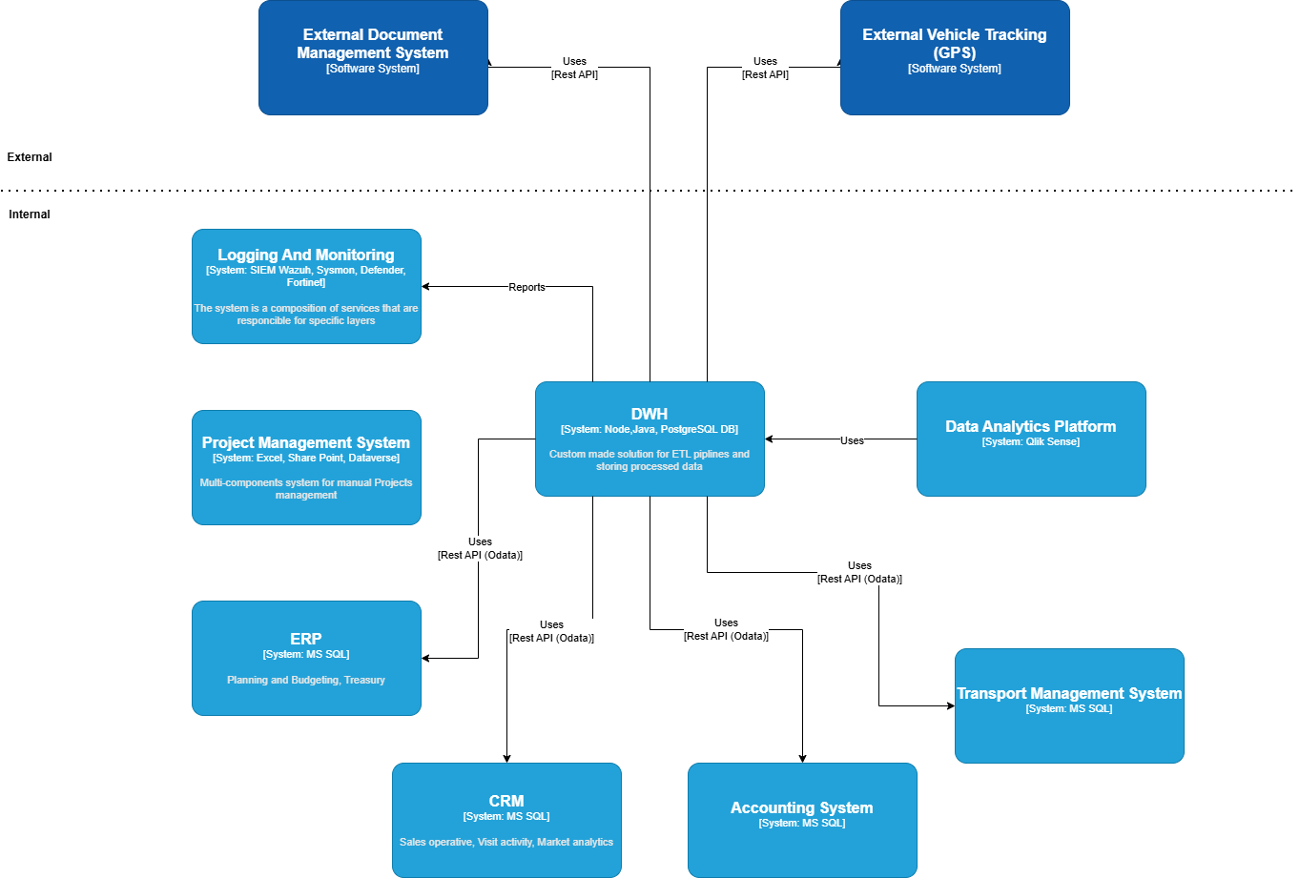

Systems and services
# | System | Description
1 | OData-based systems | Internal business applications (such as ERP, planning) that provide access to operational and financial data through OData REST APIs within the internal infrastructure.
2 | BAF | Accounting and transport management systems that provide access to operational and financial data through OData REST APIs within the internal infrastructure.
3 | MS SQL | Microsoft SQL Server includes several key data domains, which are accessed directly within the internal network or through API connections for analytical and reporting purposes.
4 | Systems exposing data via RESTful APIs | A set of internal and external systems, including Azure DB and Share Point, that exchange data through REST API endpoints. These integrations enable automated data retrieval, synchronization, and interaction with external services.
5 | Excel | Used as an internal data source for manual input, local data storage, and departmental reporting. Excel files are shared within the organization and can be integrated into analytical workflows through connectors or automated import processes.
6 | Dataverse | A cloud-based data service used for structured data storage and integration with other business applications. Data is available through the OData Web API, enabling consistent access and automation within internal business processes.
7 | Qlik Sense | A business intelligence and data visualization platform used for building dashboards and analytical reports. It allows users to connect to various data sources, perform transformations, and create interactive visualizations for business analysis.

Data Processing
Data processing within Gladpharm is currently performed through an internally developed integration platform. This system manages ETL/ELT workflows — data extraction, transformation, and loading — and supports horizontal scalability to handle growing data volumes.
Processed data is then loaded into analytical environments such as Qlik Sense, where it is used for reporting, performance monitoring, and management dashboards.

Data Migration needs
Migrating data from an existing solution, especially when it comes to historical data, requires careful planning and several specific requirements to ensure a smooth, secure, and successful process.
Here are the key requirements for this process:
- Database size and complexity: Estimate the size of the database and the complexity of its schema, including tables, indexes, stored procedures, triggers, and functions.
- Performance requirements: Assess the current performance.
- Initial data loading: Perform an initial bulk transfer of historical data to the cloud environment.
- Incremental data upload: If required, use incremental data upload techniques to synchronize changes made during the initial upload phase.
- Verify data: Validate the migrated data to ensure that it matches the source data in terms of integrity and consistency.

Performance requirements and data transfer requirements.

Data Processing Schedule
Data Source | Processing Deadline | Average Processing Time | Maximum Processing Time
Raw Data (ERP, external) | 05:00 AM | 2 hour | 3 hours
Dimensions Data | 5:30 AM | 15 min | 1 hour
Fact Tables | 7:00 AM | 30 minutes | 1 hour
Data Marts | 8:00 AM | 20 minutes | 40 minutes

Incoming data volumes per source
Source | Daily data volume, MB | Data type | Location
ERP | 6 | Structured data exposed via OData protocol | Internal server
Accounting System | 2 | Structured data exposed via OData protocol | Internal server
Transport Management System | 3 | Structured data exposed via OData protocol | Internal server
MS SQL | 60 | Relational data (MS SQL) | Internal server
Excel (Project Activity) | 0.1 | Flat files (Excel / CSV) | Local computers
Azure DB (Document Management) | 0.5 | Semi-structured data (JSON from REST API) | External
Vehicle Tracking (GPS) | 0.5 | Semi-structured data (JSON from REST API) | External
Other Sources (SharePoint, Dataverse) | 0.3 | Semi-structured data | Internal server

Performance and SLA Considerations
Performance Metric | Requirement
Data processing during peak times (EoM/EoQ/EoY) | Should not impact existing SLAs; prioritize new data
Response time for 80% of standard queries | Within 2 minutes
Impact of ad-hoc queries on solution performance | None (should not affect data processing, refreshes, etc.)
The data presented above are approximate estimates based on currently available information. Actual volumes may vary depending on the reporting period, business activity, and integration frequency. These figures are intended for initial planning and assessment purposes and can be further refined.

Users and roles

# | Role | Description
1 | Administrator | Manages infrastructure, user access, and security settings.
2 | Support | Monitors solutions, handles deployments, and ETL/ELT processes. Focuses on PROD environment with read-only access to address user questions and issues.
3 | Power BI Developer | Develops reports and dashboards with read-only access.
4 | Developer | Manages development processes with full control over the DEV environment. Can modify the solution codebase for each component if necessary. Has read-only access to PROD environment.
5 | DevOps | Automates deployment processes. Implements IaC principles using Terraform HCL.
6 | Data Owner | Manages data, including access permissions, usage policies, and monitoring data usage.
7 | Data Analyst | Handles data analysis processes, develops new data marts, and optimizes existing processes.

# | Role | Members
1 | Administrator | TBD
2 | Support | TBD
3 | Power BI Develop | TBD
4 | Developer | TBD
5 | DevOps | TBD
6 | Data Owner | khomenko.r@gladpharm.com
7 | Data Analyst | khomenko.r@gladpharm.com

Data classification and related risks
Data Source | Description | Classification | Risk
ERP | Stores core enterprise data related to financial planning, budgeting, treasury operations, and internal cost management. | Restricted | High risk — contains sensitive financial information; unauthorized access could result in financial loss or compliance violations.
Accounting System | Holds accounting records, general ledger entries, and financial reporting information and management accounting. | Restricted | High risk — includes confidential financial data; exposure could cause financial misstatements or regulatory non-compliance.
Transport Management System | Contains operational data on fleet management, vehicle usage, routes, and logistics performance. | Internal Use Only | Medium risk — may expose internal logistics operations and transport schedules.
MS SQL | Includes data domains: Operational Sales (sales transactions and performance data), Visit Activity (information about promotional interactions of medical representatives with healthcare professionals, conferences, and digital communication), and Market Analytics (data on market trends and competitive positioning). | Confidential | High risk — includes personally identifiable and commercial data; unauthorized access may cause privacy breaches, reputational harm, or competitive disadvantage.
Excel | Contains project management data, including task tracking, timelines, deliverables, and resource allocation information. | Internal Use Only | Medium risk — exposure could reveal internal project structures, delivery timelines, or confidential development information.
Azure DB | Stores business documents, contracts, and approval workflows exchanged internally and with external partners. | Internal Use Only | Medium risk — unauthorized access could expose internal or partner documentation and agreements.
Vehicle Tracking (GPS) | Holds data on vehicle locations, movement history. | Internal Use Only | Medium risk — exposure may reveal logistical patterns, transport routes, or internal mobility details.
Other sources (Share Point and Dataverse) | Contain semi-structured and reference data used for collaboration, document storage, and cross-departmental integrations. | Internal Use Only | Medium risk — exposure may reveal internal documents, shared resources, or integration data used in operational processes.

Network Architecture

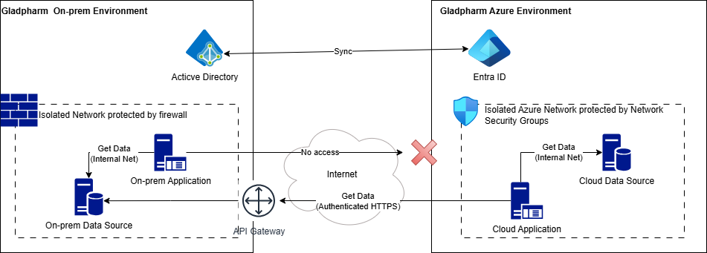

The customer’s infrastructure is a hybrid IT system, hosted within:
- Local data centers and secured by Fortinet network appliances, which provide perimeter protection, traffic filtering, and basic intrusion prevention capabilities.
- Azure Environment with isolated cloud network protected by Azure services such as Network Security Groups.
There is currently no dedicated private channel to Azure such as ExpressRoute or VPN Gateway, meaning that all communication with external or cloud services occurs over the public internet using standard secure protocols (HTTPS, TLS). IP Allow lists and Obligatory Authentication provides additional layer of defense.
Network and endpoint monitoring are handled through Fortinet ecosystem, which serves as the central network management system for on-prem Data Center.
- The organization gathers a comprehensive set of logs, including:
- Security agent logs and system events from endpoints.
- Sysmon data such as process launches, file creations, and DNS queries.
- Audit logs from Microsoft Defender.
- Fortinet network traffic logs, capturing ingress and egress flows.
At present, the environment does not utilize Azure Monitor or Log Analytics, and there is no centralized telemetry pipeline covering both on-premises and cloud resources. Monitoring is therefore siloed, focusing mainly on infrastructure-level and security events rather than application-level observability.
Connectivity from cloud application to on-prem data sources is established through authenticated public endpoints served by custom API Gateway instances. Identity management and access control is handled on a per-system basis, with limited integration into a unified identity provider such as Azure AD.
Both on-prem Active Directory and Azure Entra ID a configured to perform synchronization.

Security and Compliance needs
Security Measure | Explanation
Data Encryption | Implement encryption at-rest to protect sensitive data, such as actual income. This ensures that even if unauthorized access occurs, the data remains unreadable and unusable, safeguarding its confidentiality and integrity.financial indicators.
Access Control | Utilize access control mechanisms to restrict access to the analytical solution and its underlying data. Implement role-based access control (RBAC) to ensure that only authorized personnel have access to specific data and functionalities based on their roles and responsibilities.
Secure Communication | Employ security protocols (e.g., HTTPS) to encrypt data transmission between different components of the analytical solution, including sources, integration components, data warehouse, analysis tools, and user interfaces. This prevents data tampering during data exchange, enhancing data confidentiality and integrity.
Geography Optimization | Optimize the solution for minimal latency for Ukrainian users, considering that all end users reside in Ukraine. Consider regional planning to address data availability and other region-specific risks, ensuring optimal performance and mitigating potential challenges.
Data Integrity Checks | Implement mechanisms to ensure data integrity throughout the data processing pipeline. Utilize hash functions to verify the integrity of data at different stages of processing, detecting any unauthorized alterations and maintaining data accuracy and reliability.
By integrating these security measures into the solution, the company can mitigate security risks, protect valuable data assets, and build trust with stakeholders. This enhances the resilience and reliability of its operations, ensuring the confidentiality, integrity, and availability of sensitive data.
Security analytical solution is crucial to protect sensitive data, maintain integrity of operations and safeguard against potential threats, The following list of security measures integrated into the solution:
- Data Encryption: Implemented encryption at-rest to protect sensitive data, such as financial indicators.
- Access Control: Access control mechanism restricts access to the analytical solution and its underlying data. Implemented role-based access control (RBAC) ensures that only authorized personnel have access to specific data and functionalities based on their roles and responsibilities within the company.
- Secure Communication (encryption in-transit): Security protocols (HTTPS) should be employed to encrypt data transmission between different components of analytical solution, including sources, integration components, data warehouse, analysis tool and user interfaces. This prevents from data tampering during data exchange.
- Geography: All end users that will use the solution resided in Ukraine. Global In this case global regions are redundant, and the solution should be optimized to have minimal latency for Ukrainian's users. Also, data availability and other region risks considered in the regional planning.
- Data Integrity Checks: Implement mechanisms to ensure data integrity through the data processing pipeline. Hash functions utilized to verify integrity of data at different stages of processing.
Integrating these security measures into the solution the company can mitigate security risks, protect valuable data assets and build trust with stakeholders, enhancing the resilience and reliability of its operations.

Resilience, Availability, and disaster recovery requirements

Customer Expectations | Solution Requirements
Expected Demand and Scalability | - Solution should absorb peak times, accommodating data volume growth up to 75% of baseline. - Peak times typically occur at month, quarter, and year ends. - Integrated monitoring system needed for scaling up components. - Data warehouse database and ETL components must support elastic scaling without recreation and minimal downtime. - Raw data stored in low-cost storage for analysis and re-processing.
Uptime and SLAs | - Solution uptime: ≥96%. - Data warehouse SLA on weekdays: ≥98%. - Maintenance window: Saturday 4 pm to Sunday 4 pm to avoid business hour disruptions.
Backup and Recovery | - Data stored on storage replicated to ≥2 data centers. - Automatic daily backups for data warehouse database. - Backup files replicated to ≥2 data centers. - Point-in-time recovery supported. - Full restore within 24 hours. - Automatic backup configured for all VMs. - Centralized configuration storage for cloud components, including change history.  Top of Form  Bottom of Form

Scalability
One of the main reasons for migrating current solutions to the cloud is scalability. The customer expectations are:
- The solution should absorb peak time when data volume can grow to 75% of the baseline. The usual peak time for the customer is EoM, EoQ and EoY.
- The customer wants to have an integrated monitoring system that advises when scale-up components are reqsuired
- Data warehouse database, ETL components should support elastic scaling up and down without re-creation and with minimal downtime
- Network connectivity between on-premises network and Azure is out of scope.
- Row data received from source systems should be stored in low-cost storage with the ability to analyze and re-process this data without access to the corresponding source system.

Backup and Recovery
- Data stored in storage should be replicated to at least two different data centers.
- Data warehouse database should have automatic backup enabled and make copies daily
- Data warehouse backup files should be replicated to at least two different data centers.
- Restore from backup should support point-in-time recovery
- Full recovery should take no more than 24 hours
- All virtual machines containing data should have automatic backup configured
- All cloud component configurations should be centralized and stored separately (including change history).

Component SLA
- Solution should have at least 96% SLA
- Data warehouse should support SLA at least 98% during weekdays
- Maintenance window from Saturday 16:00 to Sunday 16:00

Recommended changes and improvements

This document chapter covers the main opportunities and directions where the Kyivstar team sees the most valuable potential for future changes in Gladpharm.

# | Component | General Description | Detailed Description
1 | Centralized Data Platform | Establish a unified data environment for all operational and analytical needs | Implement a consolidated platform that integrates data from ERP, MS SQL, Accounting, Transport, and Project systems. This will serve as a single source of truth, simplifying access, improving data reliability, and supporting analytics and reporting at the enterprise level.
2 | Data Quality and Governance Framework | Define policies and automation for consistent, reliable data | Introduce standardized data quality rules, validation checks, and governance policies across all data domains. Automating these controls will minimize manual intervention and ensure compliance with data management standards.
3 | Templating the manual data sources | Set of policies and processes to control the manual data sources | The manual data sources are closely related to the data producers, which are humans, who can make a lot of mistakes in the data creation processes. To reduce the chance to make a mistake it’s a good practice to create the templates for manual files (for example templates of Excel files, which contains manual references)
4 | CI/CD tool | The CI/CD implementation tool | CI/CD is a very important part of the development process. The CI/CD implementation tool allows to control codebase versioning, automate the code deployment across the different environments. It is also a single source of code, which can be shared between the multiple developers

The recommended changes and improvements above aim to improve and optimize the Gladpharm existing workflows during the implementation of the new data consolidation platform. By implementing them Gladpharm can use its data more effectively to get more business value.

Use Cases
Considering the existing business challenges the next use cases aligned with business goals should be addressed
UC-ID | UC description | UC benefits | Priority
UC-01 | Enterprise Data Consolidation Platform | Build a unified data consolidation platform that integrates all operational systems (ERP, MS SQL, Finance, Treasury, Logistics, Projects, etc.) into a single, governed environment. This will provide a single source of truth, enable cross-domain analytics, and reduce duplicated data processing across departments. | 1
UC-02 | End-to-End Automation and Scalability | Implement automated data workflows and scalable pipelines to process large data volumes efficiently and reliably. This reduces manual interventions and improves performance during peak data processing periods. | 1
UC-03 | Advanced Analytical Capabilities | Develop advanced dashboards and analytics powered by high-quality, consolidated data. Automation within Microsoft Fabric reduces the number of manually built reports and provides faster, insight-driven decision-making. | 1
UC-04 | Data Governance and Quality Management | Introduce a standardized governance framework covering data validation, lineage, access control, and compliance. This will ensure transparency, accuracy, and regulatory alignment across all data assets. | 2
UC-05 | Operational Efficiency and Cost Optimization | Optimize infrastructure and data-processing resource utilization through scalable architecture, reducing total cost of ownership while maintaining performance. | 2
UC-06 | Improved User Experience and Collaboration | Provide business users and analysts with a modern, accessible data environment that simplifies collaboration, accelerates report creation, and ensures consistent use of reliable data. | 2

Proof of Value (POV) Use Case Scope

Description
The Use Case will reproduce the existing Excel report “Бюджет наступного року по ЦФВ” within Microsoft Fabric and Power BI. Data from ERP used for budgeting and financial reporting, along with reference catalogs (budget items, cost centers, and organizational units), will be ingested, transformed, and aggregated automatically, replacing manual data preparation and consolidation.
The resulting Power BI dashboard will replicate the structure of the current Excel report, allowing filtering by organization, CFR, cost center, employee, and period, with export options for management review.

Scope
- Data sources: ERP database
- Output: Power BI budget report with an agreed structure
- Processes tested: data ingestion, transformation, reporting
- Evaluated: data accuracy, report responsiveness, refresh speed, and user interactivity

Expected Outcomes
- Demonstrated automation of previously manual Excel-based budgeting and reporting workflows
- Reduced manual effort through automated data ingestion, transformation, and refresh processes in Fabric
- Improved data accuracy and consistency by consolidating data in a single environment
- Showing how Microsoft Fabric simplifies reporting, ensures data integrity, and provides a scalable foundation for future analytics at Gladpharm

Success Criteria
The Proof of Value will be considered successful if Microsoft Fabric enables the full automation of the report previously created manually in Excel, daily or on-demand refresh through Fabric pipelines, and delivery of an interactive Power BI report that replicates the existing structure while significantly reducing manual effort and demonstrating readiness for scalable, governed analytics within Gladpharm.

Data Processing

- The source data is stored with monthly granularity
- Data from ERP instance will be transmitted through a REST API using OData protocol.
- Time table of data collection: 1 time per day from January to September. 1 time per hour – from October to December.
- Perform a Full Reload of the DWH.

Structure of Storage
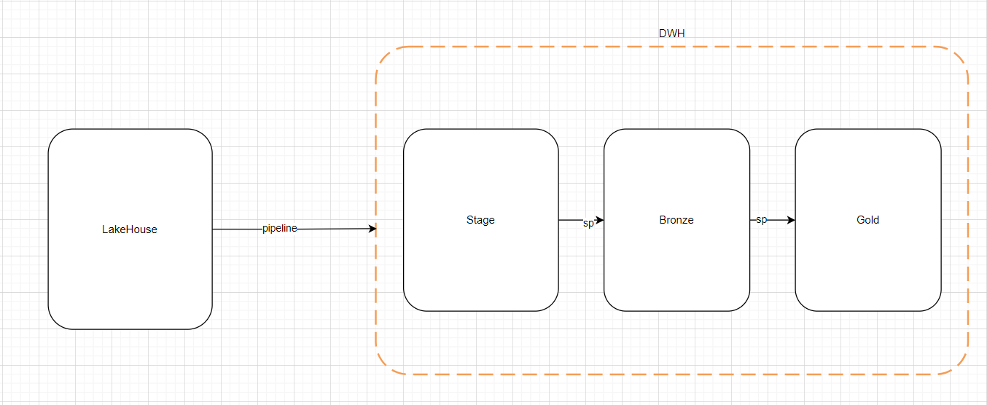
The whole ETL flow is described on the following diagram:

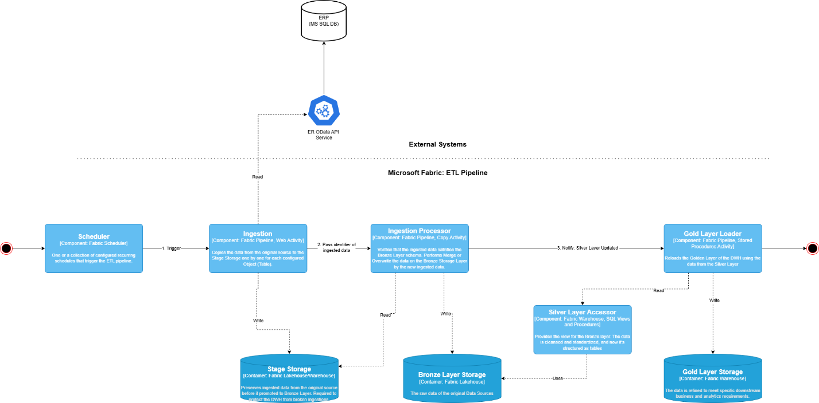

As an initial requirement business expects to see following objects to be imported:

- Статьи Бюджетов
- Статьи Оперативных Бюджетов
- Статьи ОБ_СтатьиБюджета
- Пользователи
- Структура Предприятия
- Организация
- Каз_БюдАдминВитрат_
- ОБ_АдмінВитрат_RecordType
*** First 6 objects are Dimensions and next 2 are Facts

These objects are stored on Lakehouse as-is with following the naming convention:
- system_name_schema_name.src_tbl_name
- Each table contains following technical fields:
  - TechExecutorRunID
  - TechProcessorRunID
  - TechProcessingDateTime
  - TechBusinessDateTime

The latest data snapshot is transferred into Stage layer of DWH as-is using pipeline with the DROP TABLE IF EXIST option
Data is then moved to the Bronze layer as-is through store procedure which accepts table name, and strategic of loading data (SCD1, SCD2, Full) as parameters.
The Gold layer contains single fact table with deformalized data based on the mentioned tables above and Calendar table. These table are linked by sk_date_id. Table name is FctSpends, which is fed by store procedure with Full Reload approach. Gold table contains surrogate key – sk_fct_spends and technical fields created_at and created_by. Since multiple source fact tables exist, the FctSpends table includes a key field named SpendsType, which indicates the originating source table.
Schema of Gold Layer:
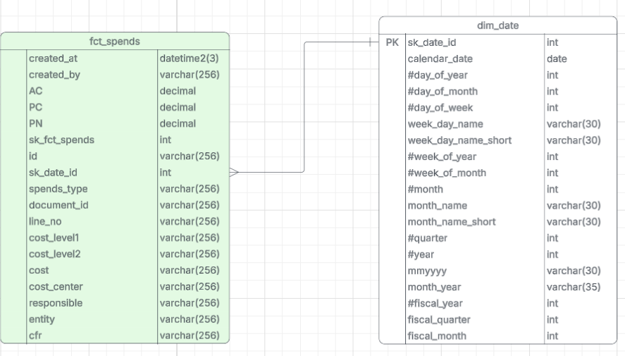

There is mapping of the columns, which describes how fact table is built:
Source Table.Column | Target Column | Comment
Сурогатний ключ (ID) | sk_fct_spends
ОБ_АдмінВитрат_RecordType.Recorder | id
Каз_БюдАдминВитрат_.Recorder | id
ОБ_АдмінВитрат_RecordType.Period | sk_date_id | 20260101
Каз_БюдАдминВитрат_.Period | sk_date_id | 20250101
SourceFlag(Actual2025, Planning2025) | spends_type | будувати на основі Recorder_Type
ОБ_АдмінВитрат_RecordType.Документ_Key | document_id
Каз_БюдАдминВитрат_.Документ_Key | document_id
Каз_БюдАдминВитрат_.LineNumber | line_no
Каз_БюдАдминВитрат_.LineNumber | line_no
Статьи ОБ | cost_level1
Статьи ОБ | cost_level2
Статьи ОБ | cost
Структура Предприятия.Description | cost_center
Пользователию.Description | responsible
Организация | entity
Структура Предприятия.Description | cfr
ОБ_АдмінВитрат_RecordType.Сума | PC,AC,PN (Total) | StandardODATA.Document_ЗаявкаНаРасходованиеДенежныхСредств *-1
Каз_БюдАдминВитрат_.Сума | PC,AC,PN (Total) *-1

Applications Infrastructure/networking components

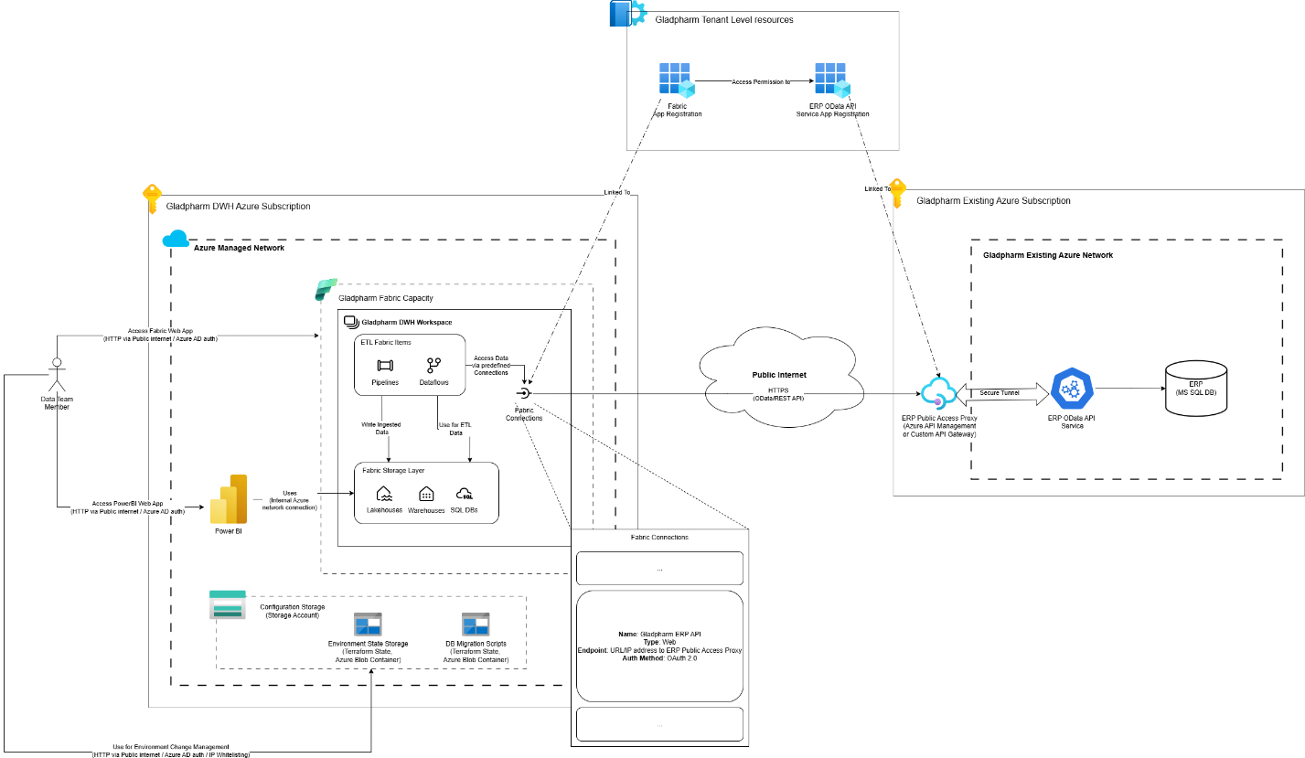

Building the POV solution we will rely on existing approach with providing the access to the customer data sources using API gateway with the secure (TLS, HTTPS) and Authenticated (OAuth 2.0) connections established via public internet.

Visual representation of As IS vs Future Landscape

As IS Landscape
The data is analyzed and aggregated for further processing. After aggregation, it is enriched with proprietary information (such as project and division mappings). Reports are then prepared manually, and the results are distributed to users via email. Although a dedicated Data Warehouse and Analytics system exist within the client’s landscape, the complexity of onboarding new processes through custom development prevents the process from being fully automated.
The process starts with manual data collection from
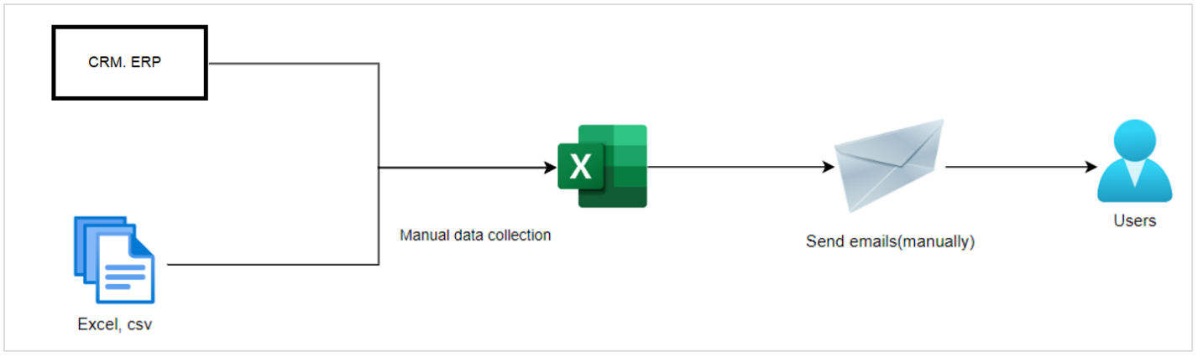
Future Landscape

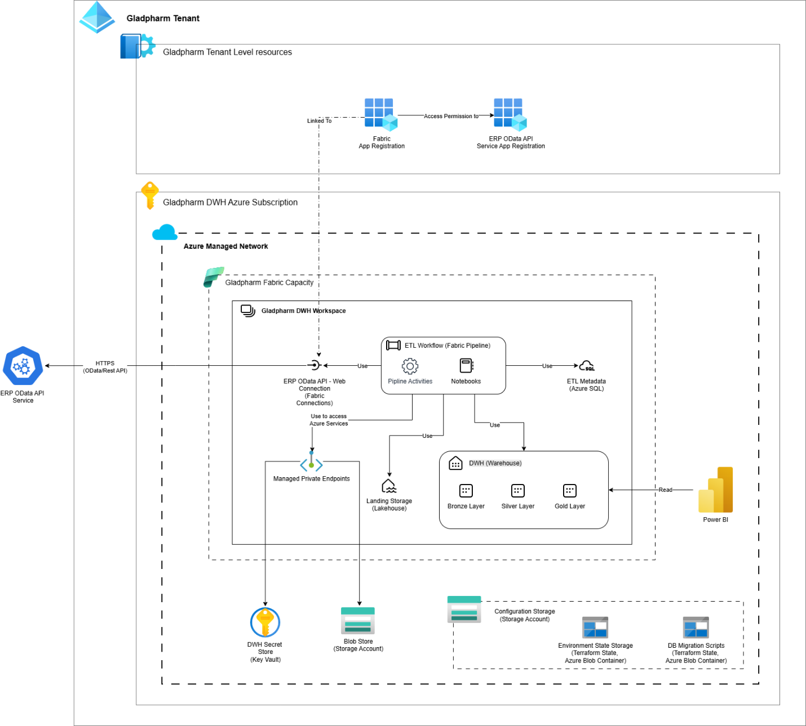

The solution contains:
The proposed solution is based on Microsoft Fabric and deployed in the Azure. It connects to the on-premise data source from Gladpharm’s environment using publicly exposed REST API managed by Azure API Management protected by OAuth 2.0 authentication layer. The data is ingested using OData protocol . The architecture ensures scalability, performance, and end-to-end security while enabling seamless integration between data sources, data storage, and analytical tools.

Azure DWH Environment

- Gladpharm DWH Workspace: The main Microsoft Fabric Workspace that is a part of the Gladpharm Fabric Capacity. All the Fabric Items needed for ETL process and DWH storage are hosted in it, such as data pipelines, notebooks, lakehouses, and warehouses
- Tennant level App registrations: The Azure App registrations and their configuration needed for establishing a secure and authorized connection between Fabric Activities and the Data Source’s APIs.
- Key Vault: Manages encryption keys, credentials, and connection strings used by pipelines or infrastructure provisioning tools.
- Storage Account: Cloud-based storage for manual datasets, configuration files or other static assets required for ETL process.
- Configuration Storage: Azure Storage account required for performing the environment configuration management done by infrastructure provisioning tools.

Provisioning and configuration management will be performed using Terraform HCL for infrastructure and Configuration management of DWH platform. The DB Schemas of DWH Storage Layer will be managed using Flyway migrations.

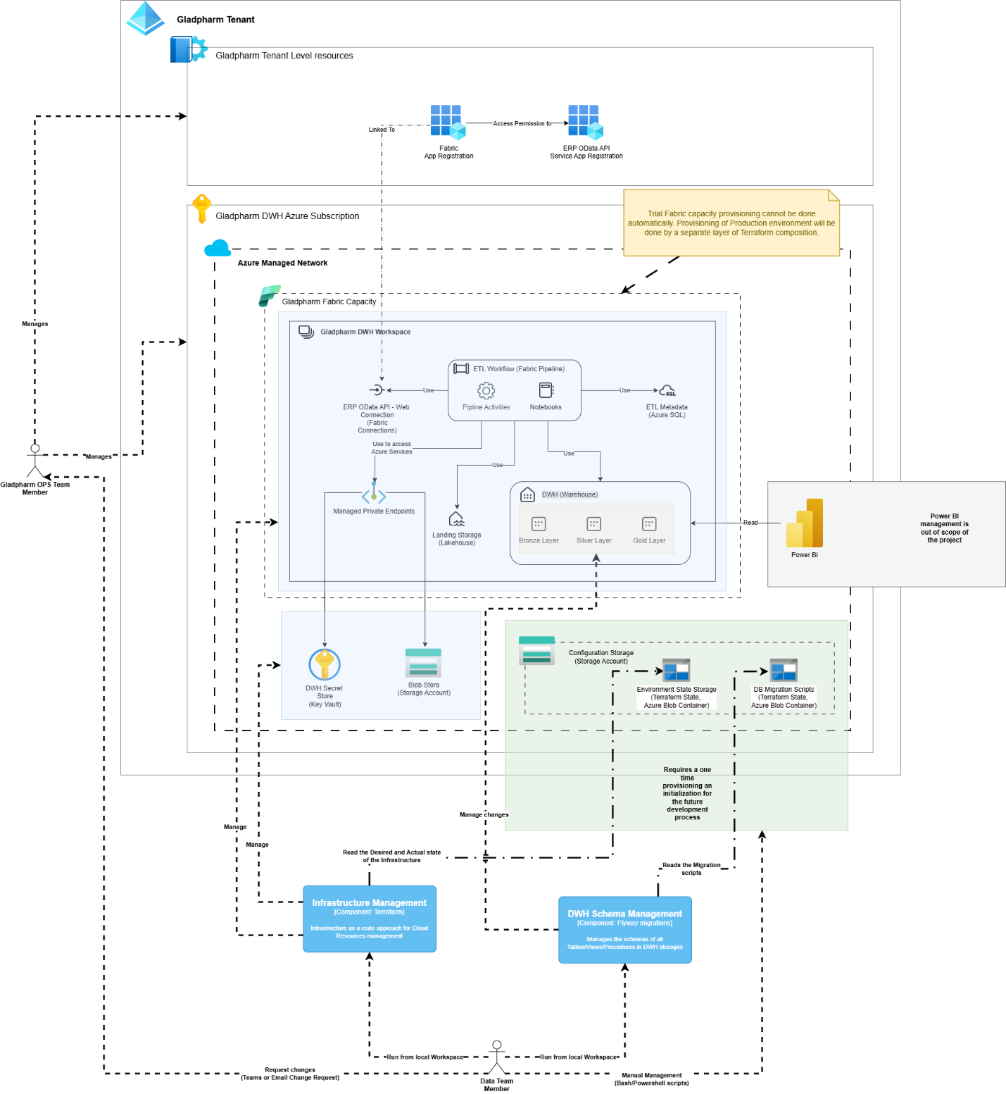

3. Data Processing and Storage Layers
- ETL Workflow: The Fabric Pipeline that performs an orchestration of the ETL flow. Contains Data Pipeline activities and Fabric Notebook calls required for performing all needed stages of the ETL Workflow.
- Pipeline Activities: A set of Fabric pipeline’s predefined actions that handle automated data ingestion, transformation, and loading (ETL/ELT) from MS SQL, ERP, and manual sources.
- Notebooks: Used for data actions that are not covered by Fabric Pipeline’s activities or that required complex logic.
- ERP OData API Connection: preconfigured API client for the external ERP Data API Service. Required for Fabric Items to connect to external API services.
- Managed Private Endpoints: allows secure and private access to data sources or services that are not a part of the Fabric but managed by the Azure Platform itself.
- DWH: Serves as the central repository for raw and curated data, organized into the Bronze, Silver, and Gold layers:
  - Bronze Layer: Raw data ingested from source systems without transformations.
  - Silver Layer: Cleaned and standardized data, ready for analysis or integration.
  - Gold Layer: Aggregated and business-ready datasets used by reporting tools.
- Landing Storage: a storage for temp data ingested by the ETL Workflow before promotion it to the DWH. Required for protection of the DWH from the partial changes done by the failed ingestion processes.
- ETL Metadata: Store metrics produced by the ETL Workflow. Also stores other metadata required for it.

4. Reporting and Visualization
Microsoft Power BI: The primary visualization and reporting tool connected to the DWH, mainly to the Gold Layer.

Deployment Plan

Based on the project business goals, we recommend to implement solution within following phases:

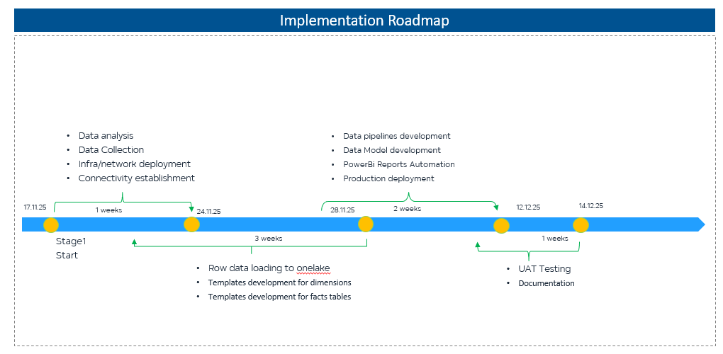
Phases of PoC | Tasks | Start Date | End Date | Work Results
Stage 1 – Data Analysis & Infrastructure Setup | • Data analysis  • Data collection  • Infra & network deployment | 03.11.25 | 14.11.25 | • Full understanding of data sources  • Connected environments  • Ready infrastructure for next steps
Stage 2 – Model & Report Development | • Model development  • BI report development (non-automated)  • Initial testing | 14.11.25 | 19.11.25 | • First working version of the model  • Draft BI report  • Verified logic & data structure
Stage 3 – Pipeline & Automation Development | • Data pipelines development  • Modelling automation  • Power BI report automation  • Deployment to production environment | 19.11.25 | 02.12.25 | • Automated pipelines  • Automated model refreshes  • Automated BI report refresh  • Deployed PoC solution
Stage 4 – UAT & Documentation | • UAT testing  • Documentation | 02.12.25 | 09.12.25 | • Validated PoC by business users  • Final PoC documentation & knowledge transfer

Phases of scaling | Tasks | Start Date | End Date | Work Results
Stage 1 – Architecture & Infrastructure Setup | • Fabric Capacity (F16/F32) provisioning  • Dev/Test/Prod workspaces & RBAC  • Network & Gateway configuration  • Initial Lakehouse structure: Stage/Bronze/Silver/Gold  • Security setup: encryption, access control, audit | 05.01.2026 | 19.01.2026 | • Ready and secured Fabric platform  • All environments prepared for development
Stage 2 – Data Ingestion & Integration Setup | • Onboarding all data sources: MS SQL, Odoo CRM, Odoo Retail, Respos API, NIQ, Yieldigo  • Building ingestion pipelines for each source  • Establishing data retention rules  • Manual file templating & validation (CSV/Excel) | 19.01.2026 | 09.02.2026 | • Unified ingestion layer  • Standardized manual data upload process  • Stable daily data collection
Stage 3 – Modelling, Automation & CI/CD | • Full Bronze → Silver → Gold transformations  • Business models for all entities (≈1000 objects)  • Data Quality Framework (schema checks, load completeness, alerts)  • Pipeline orchestration & dependency management• CI/CD implementation (Dev → Test → Prod), Git versioning | 09.02.2026 | 05.03.2026 | • Automated data pipelines  • End-to-end model automation  • CI/CD ready development lifecycle  • Data quality monitoring in place
Stage 4 – Reporting, Performance, Migration | • Migration of historical data (≈1 TB)  • Migration of existing Power BI reports  • Development of new reports & semantic models  • Performance tuning (EoM/EoQ/EoY scenarios)  • SLA verification & load optimization | 05.03.2026 | 25.03.2026 | • Full historical data in Fabric  • Optimized reporting environment  • Confirmed performance vs SLA
Stage 5 – UAT, Documentation & Go-Live | • User acceptance testing  • Bug fixing & adjustments  • Operational documentation & handover  • Go-Live & post-launch support | 25.03.2026 | 05.04.2026 | • Production-ready solution  • Team fully onboarded  • Completed full implementation

Budget

Based on a questionnaire sessions we collected the next metrics that will be used for consumption estimations:

System | Access Aproach | Access Protocol | Projected number of records per year
ERP | API Server | Odata | 2 000 000
Planning and Budgeting | API Server | Odata | 1 000 000
Treasury | API Server | Odata | 1 000 000
Accounting System | API Server | Odata | 1 000 000
Transport Management System | API Server | Odata | 1 000 000
MS SQL | Internal Network or API Server | MS SQL | 38 000 000
Sales Operations | Internal Network or API Server | MS SQL | 30 000 000
Visit Activity | Internal Network or API Server | MS SQL | 5 000 000
Market Analytics | Internal Network or API Server | MS SQL | 3 000 000
Other |  | Excel,Dataverse, Azure DB, Share Point, Rest API | 2 500 000
Project Activity | Excel | Excel | 1 000 000
 | Rest API | Share Point
 | OData Web API | Dataverse
Document Management | Rest API | Rest API | 500 000
Vehicle Tracking (GPS) | Rest API | Rest API | 1 000 000
 |  |  | 44 500 000

Total historical data volume (actual) - preliminary 500GB-1TB. Using the Fabric Calculator guide of “If you only have the logical (un-compressed value) divide it by 6.”, we define the value of 160GB for calculator.
We were not able to collect the total number of objects in the context of the project which is the required metric for the Fabric Capacity Estimator. Based on the collected metrics and our previous experience we made the following assumptions.

- ERP System - 2M records/year
Typical ERP structure: Master data, transactional data, configuration
Record-to-table ratio: ~10,000-15,000 records per table average
Estimated: 130-200 tables
- Accounting System - 1M records/year
Typical accounting system: Chart of accounts, journal entries, reconciliations
Record-to-table ratio: ~8,000-12,000 records per table
Estimated: 80-120 tables
- Transport Management System - 1M records/year
Typical fleet system: Vehicles, drivers, routes, fuel, maintenance
Record-to-table ratio: ~15,000-20,000 records per table
Estimated: 50-70 tables
- MS SQL - 38M records/year, Highest volume
Typical data: Accounts, contacts, opportunities, activities, leads, campaigns
Record-to-table ratio: ~150,000-250,000 records per table (high transactional volume)
Estimated: 150-200 tables
- Project Activity - 1M records/year
Excel, SharePoint, Dataverse combined
Estimated: 15-25 tables (relatively simple structures)
- Document Management - 500K records/year
Typical DMS: Documents, versions, workflows, approvals
Estimated: 10-20 tables
- Vehicle Tracking - 1M records/year
Typical GPS tracking: Location points, trips, geofences, events
Estimated: 5-15 tables

Total Estimation: 440-650 tables
Most Realistic Range: 500-550 tables

Relevant for DWH: 60-70% of source tables (many technical/system tables won't be needed) - 300-385 tables

For POV we will use ERP System and Project Activity: 145-225 in total, Relevant for DWH 100-160
Microsoft Fabric Capacity Estimator:

Main scope

With corrected storage compression ratio of 160 GB:
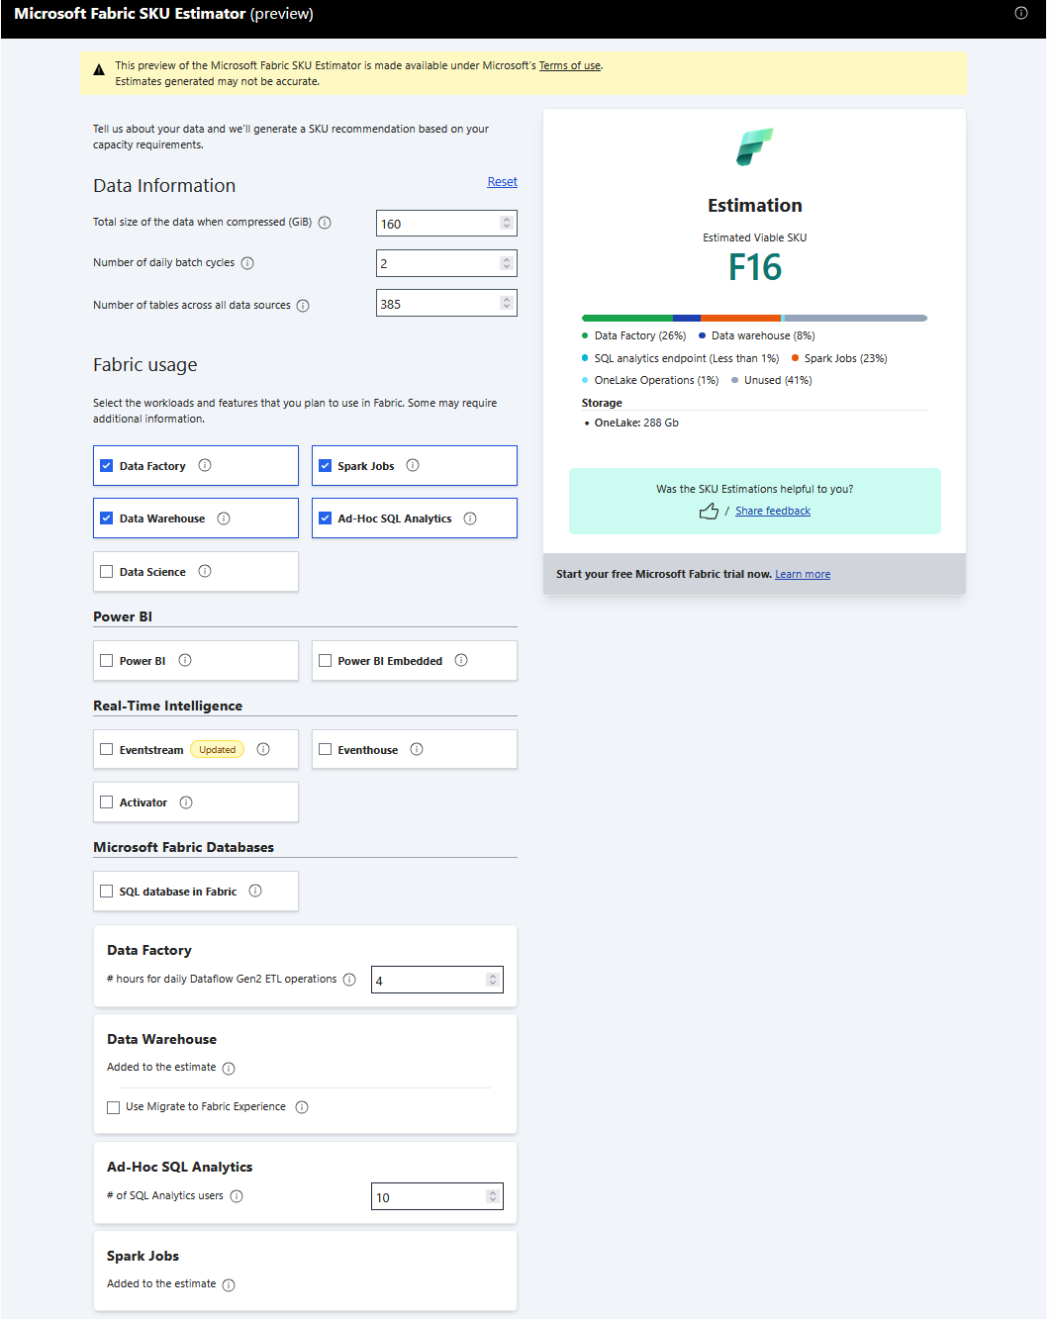

With 1TB storage:
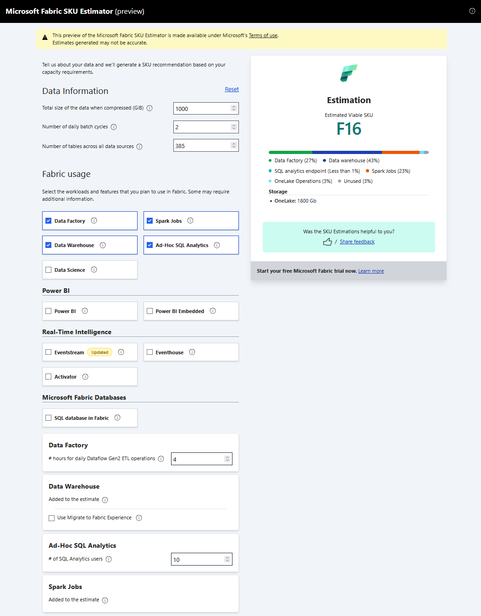

POV scope

For POV scope with ERP and Project Activity systems in the scope, let’s assume their total storage footprint is 20% of the all storage consumption. Which is 200 GB and corrected value of 35GB.

With corrected storage compression ratio of 35 GB:
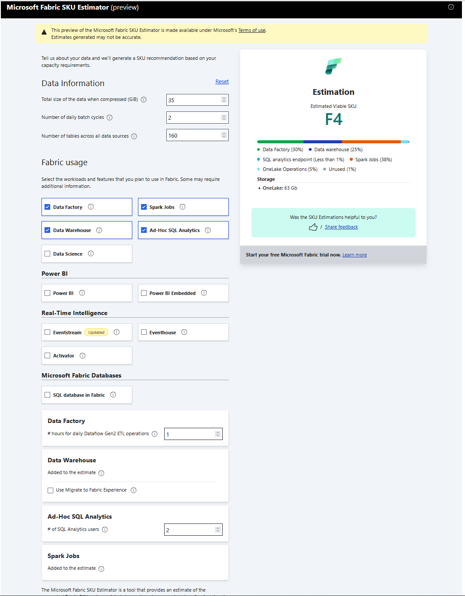
With 200 GB storage:
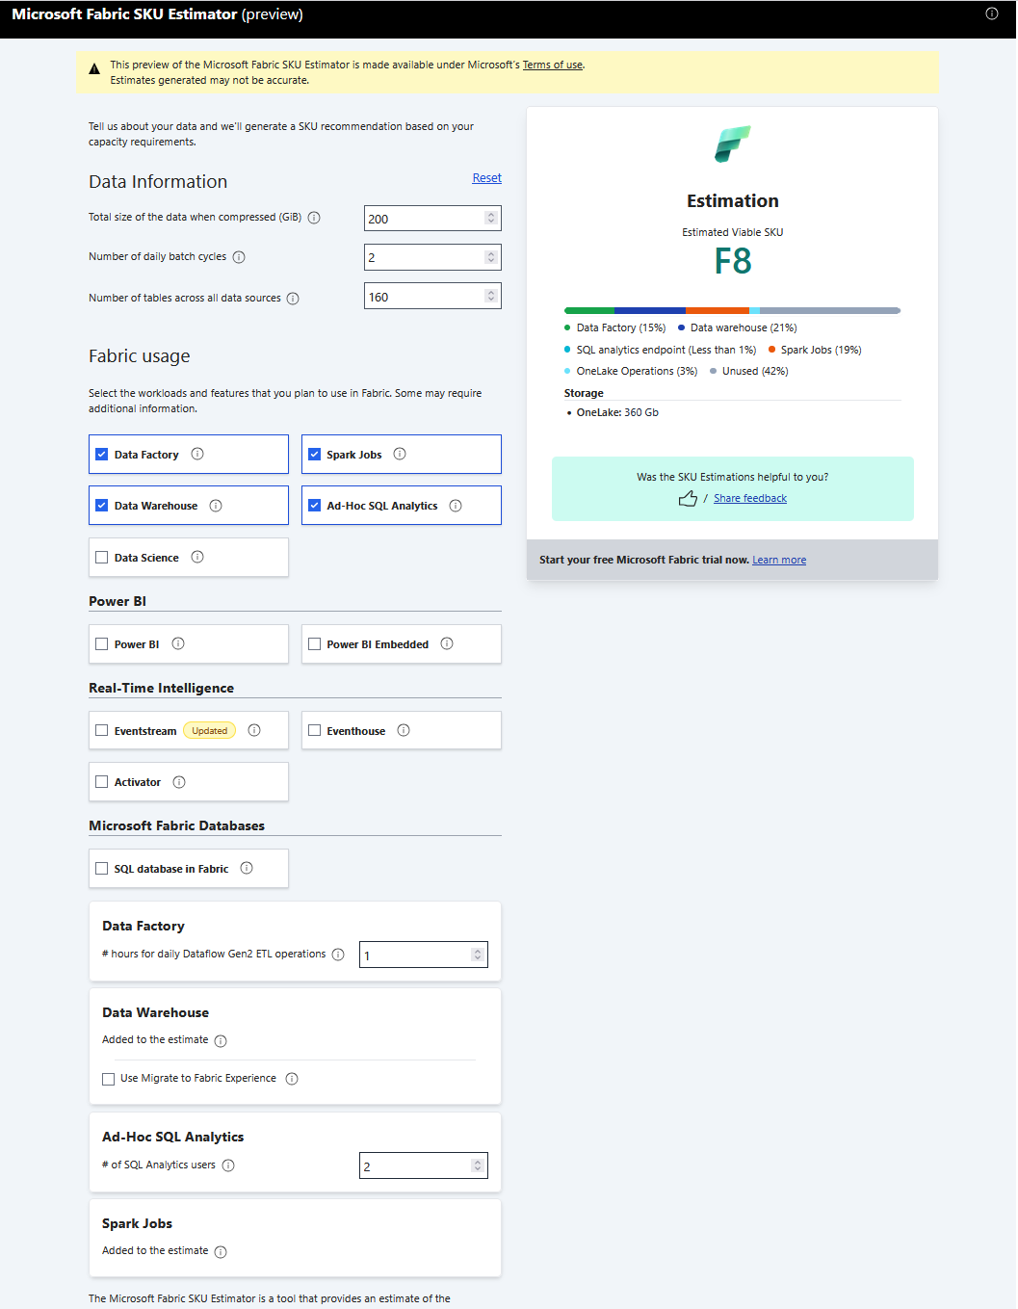

Planned Azure Consumption:

Azure calculator (North Europe is selected as cheaper region than Poland)
Main scope | MS Fabric, F16 | Calculation  Estimated monthly cost: $2,260.60  With 1 year reserved: $1,361.40
Main scope | MS Fabric, F64 with access to free read-only PowerBi licenses that can free 100 Power Bi Licenses (~$1400) | Calculation  Estimated monthly cost: $8,876.80  With 1 year reserved: $5,280.00
POV scope | F4 | Calculation  Estimated monthly cost: $555.60  With 1 year reserved: $330.81
POV scope | F8 | Calculation  Estimated monthly cost: $1,117.88  With 1 year reserved: $668.28

